**How to Sign Up for a TCC Payment Plan Online**

To sign up for TCC’s installment plan for your upcoming quarter balance, you will need to log into ctcLink.

Once you are logged into ctcLink, you will click on the “Student Homepage” button on the left.

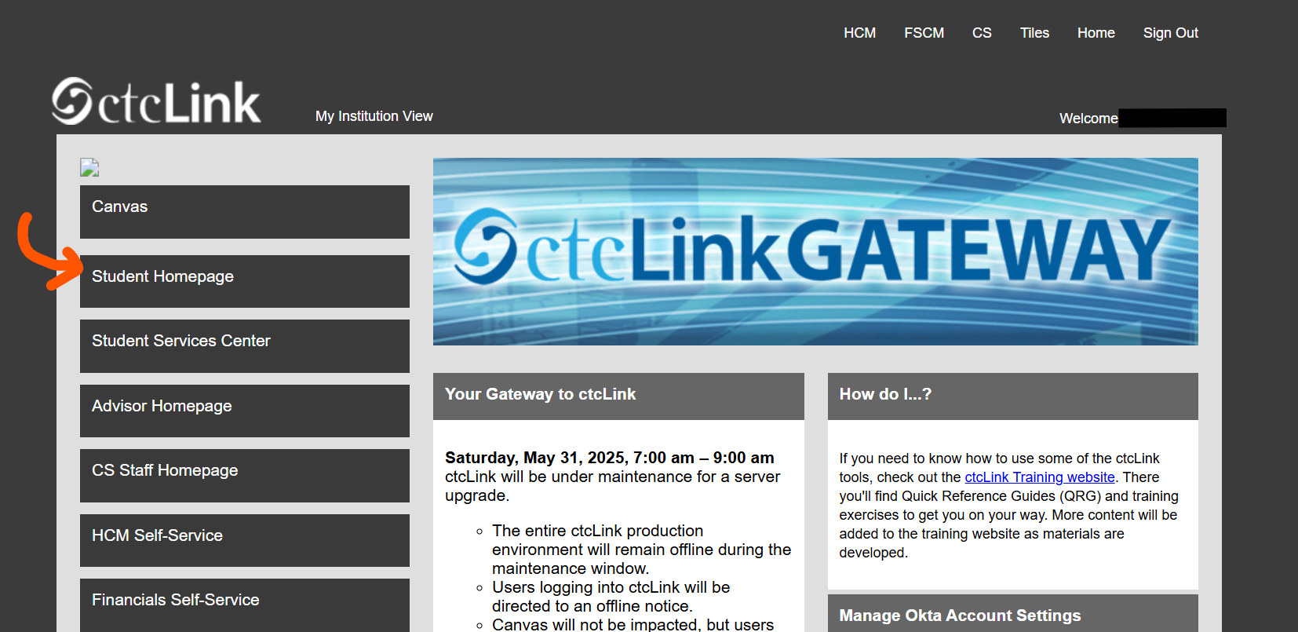

Next, you will click on the “Financial Account” Tile

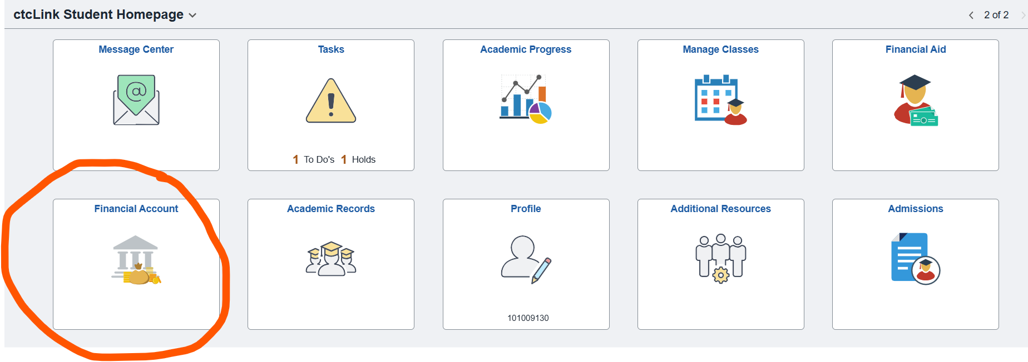

After you have clicked the Financial Account tile, you will be taken to your Account Balance.

You will need to click on the “Payment Plans” Drop-down box on the left and select “Enroll in Payment Plan”

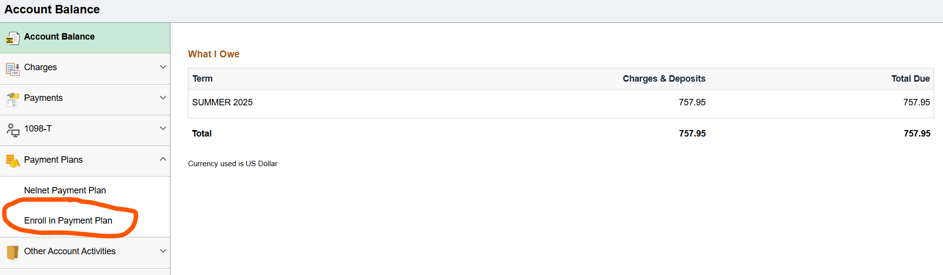

Once you have clicked “Enroll in Payment Plan” it will take you to “Select Payment Plan”.

You will need to click the bubble next to the plan to select it, and then click the “Next” button on the bottom of the page.

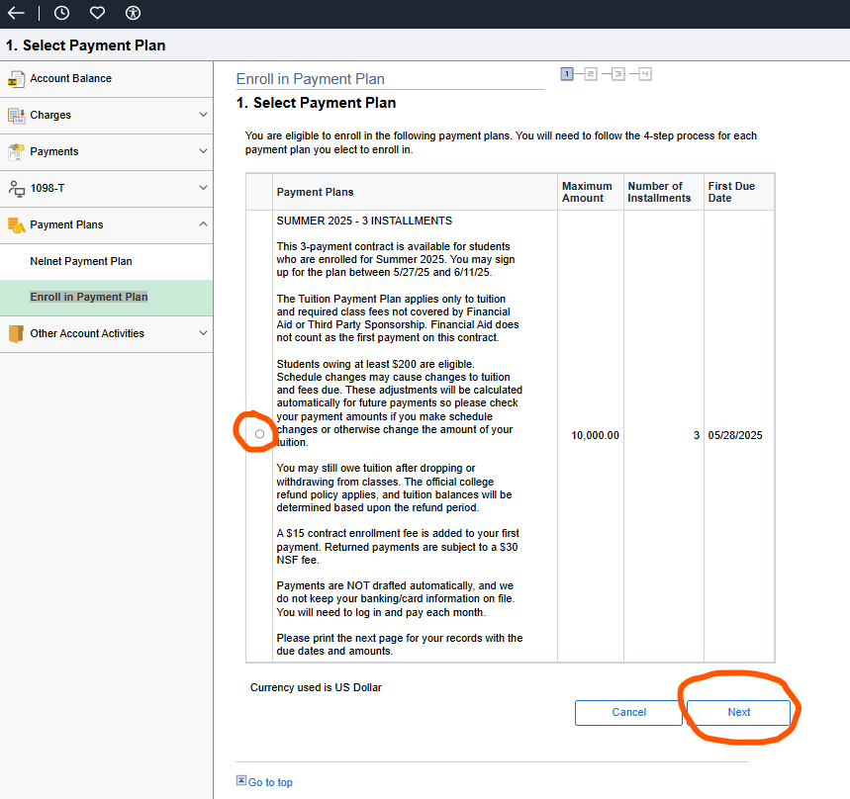

You will be taken to a screen to review the details of your payment plan.

After you have reviewed the plan, click the “Next” button at the bottom of the screen.

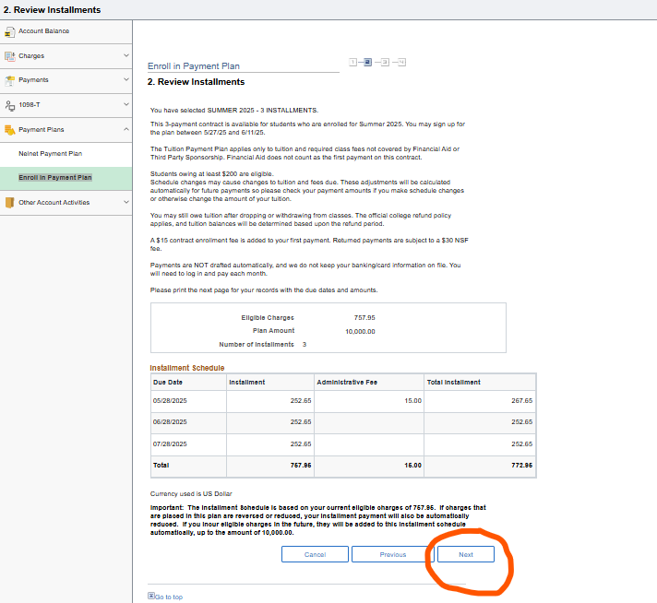

You will then be taken to the “Agreement” page.

You will need to click the “Yes, I have read the agreement” box.

Lastly, click the “Enroll” button.

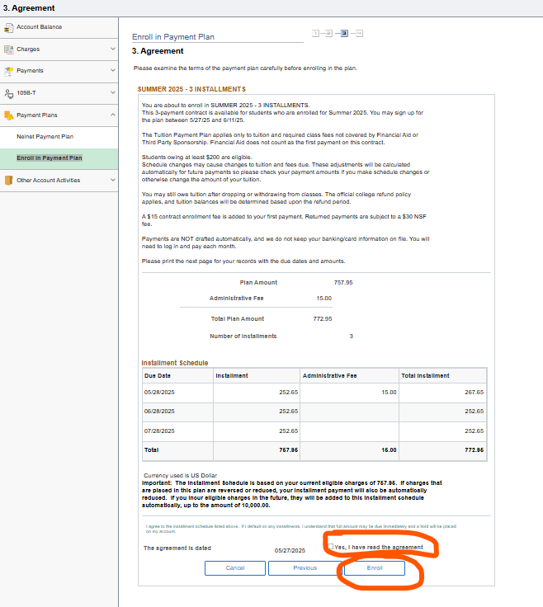

Your enrollment into the payment plan is complete. You will be taken to a confirmation page where you can click to “View my Account”.

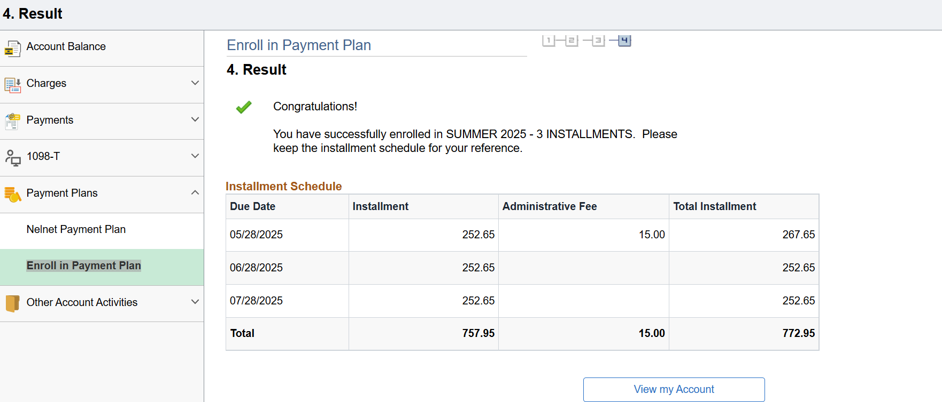

Your first installment payment including the $15 Administrative fee will need to be paid within 24 hours.

Your payments can be made online using a card through your Student Homepage in ctcLink, in person with cash, check or money order at the cashier windows in building 14, or by mailing a check or money order to:

Tacoma Community College

Attn: Cashiers; Building 14

6501 South 19th Street

Tacoma, WA 98466

If you have any further questions, please contact Student Financials at [sfs@tacomacc.edu](mailto:sfs@tacomacc.edu) or by phone at (253)566-5011.